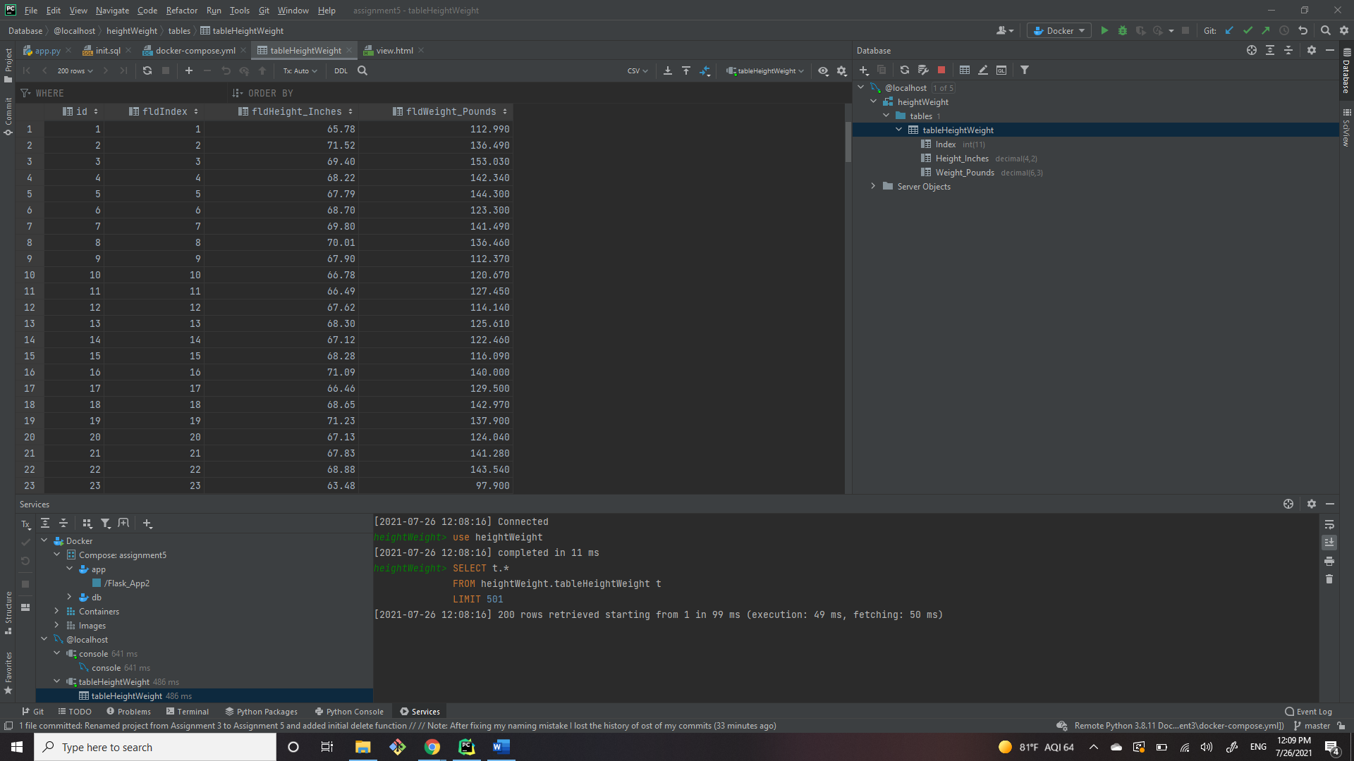PyCharm Database Screenshot

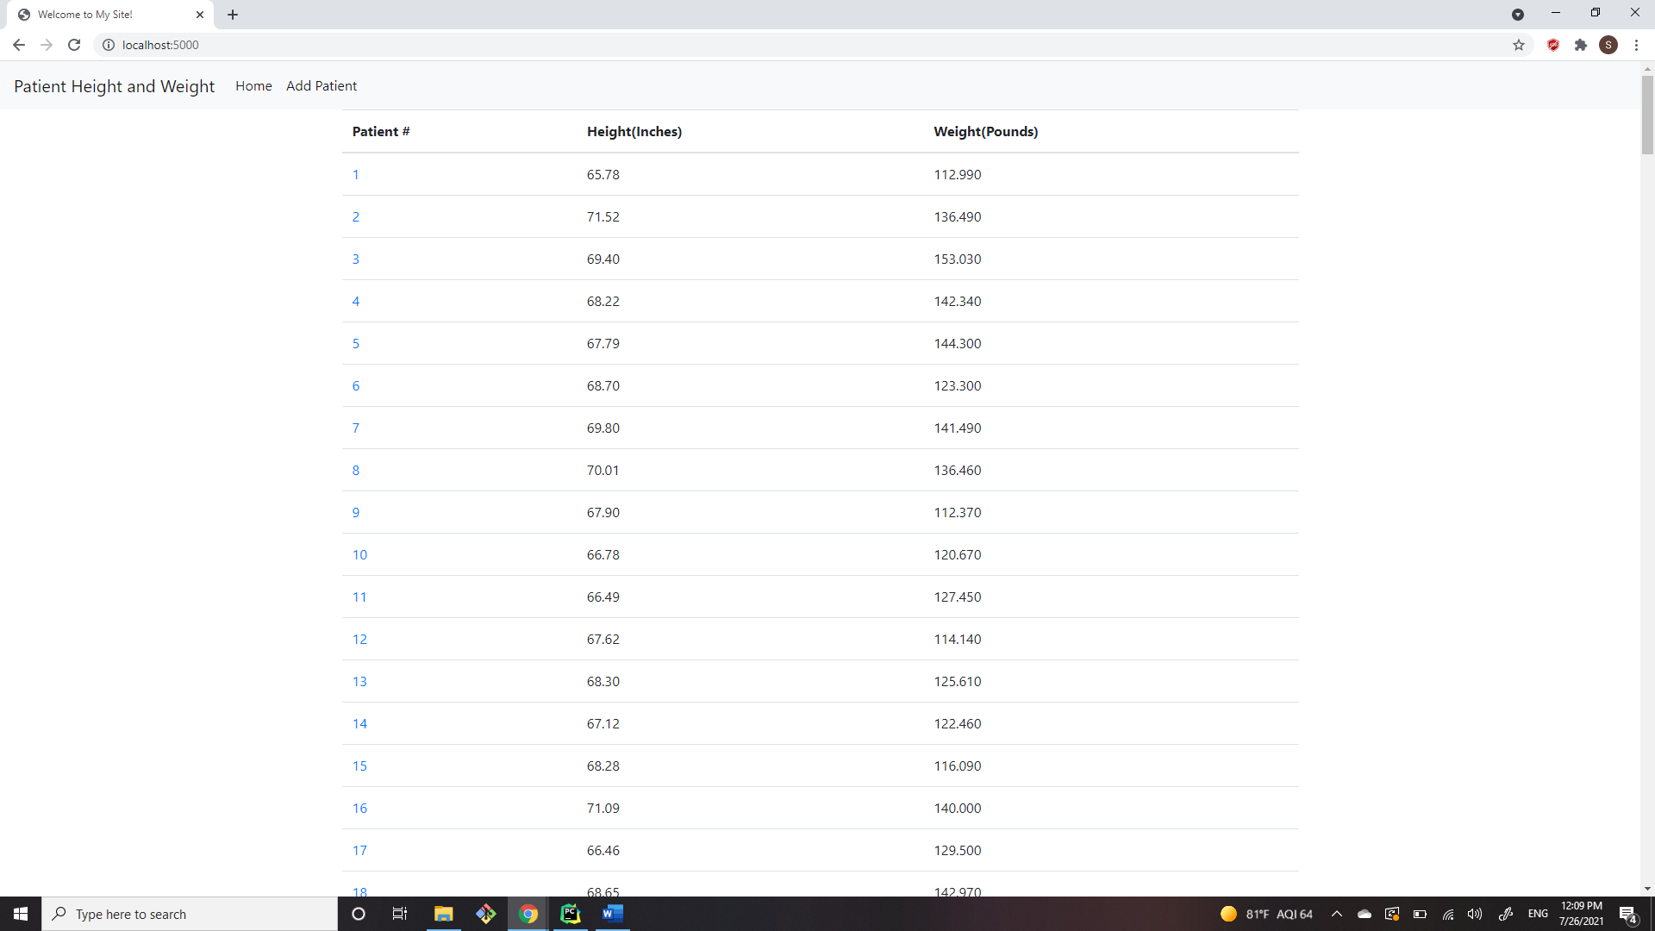Browser Homepage Screenshot

View Single Record Screenshot

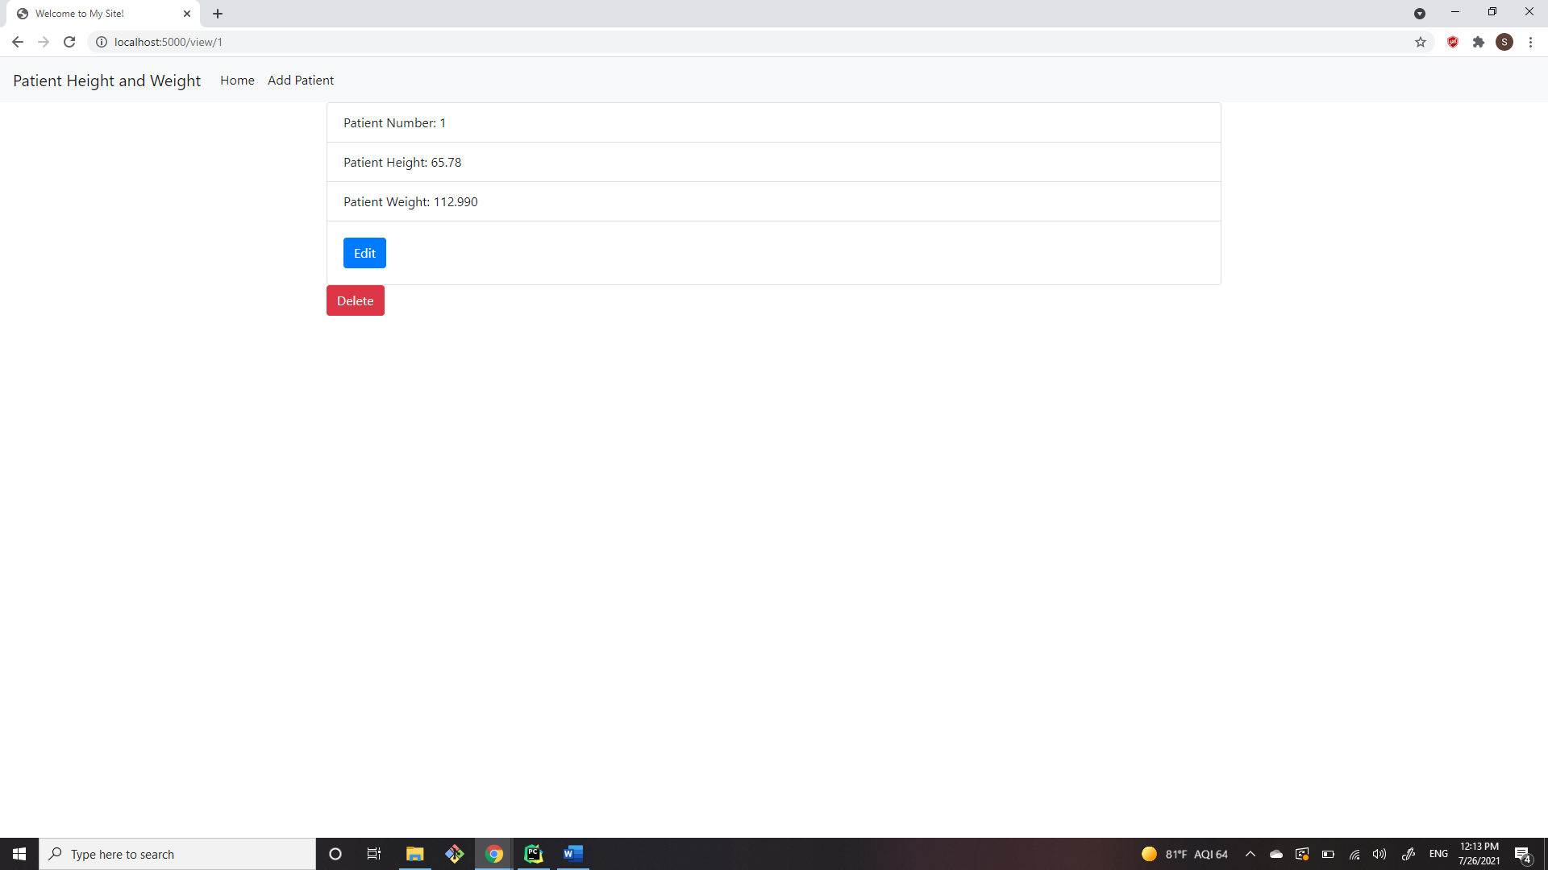

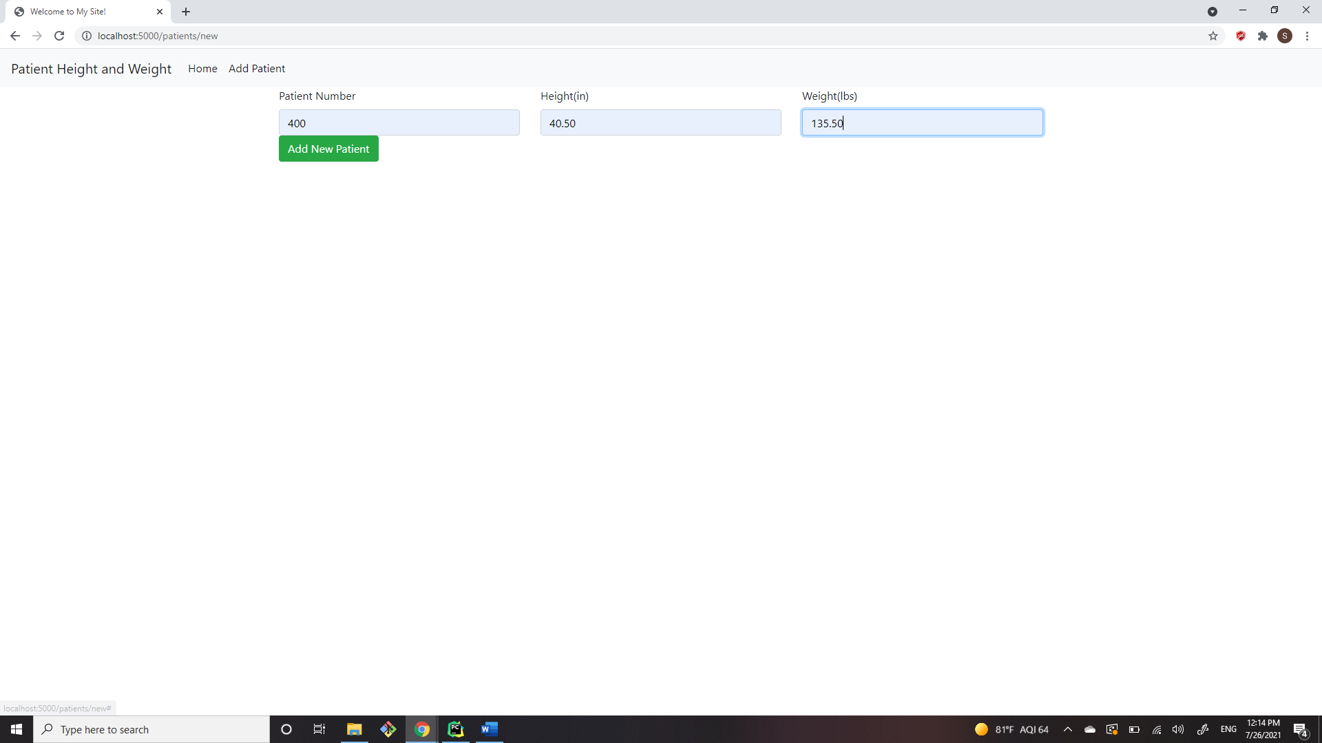New Record Screenshots

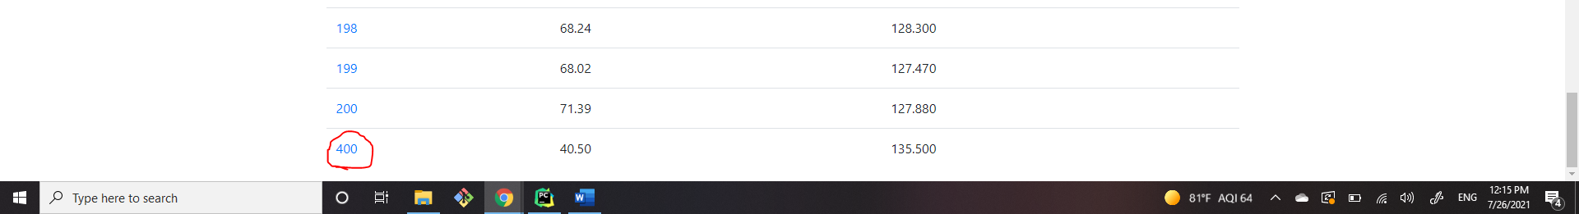

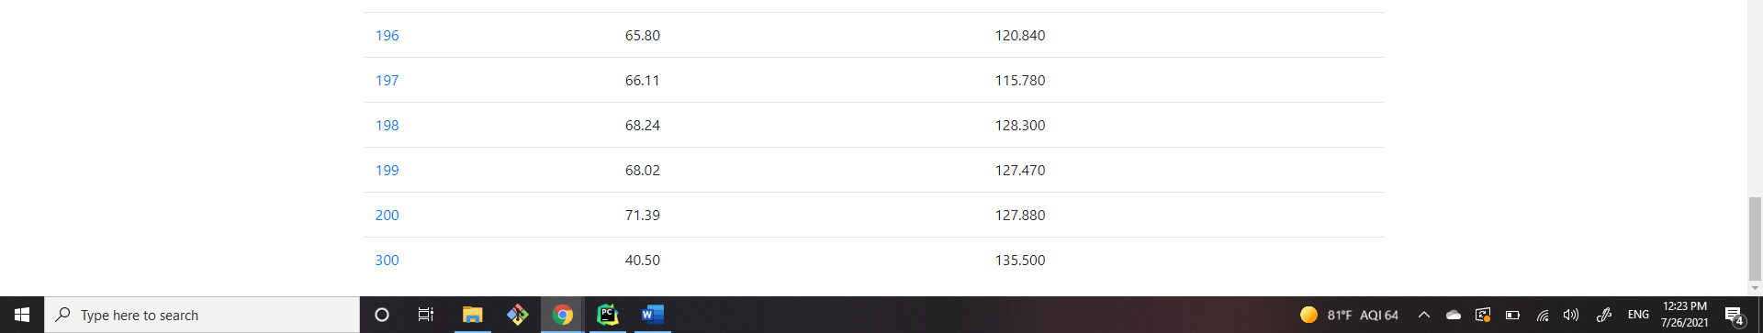 Update Record Screenshot

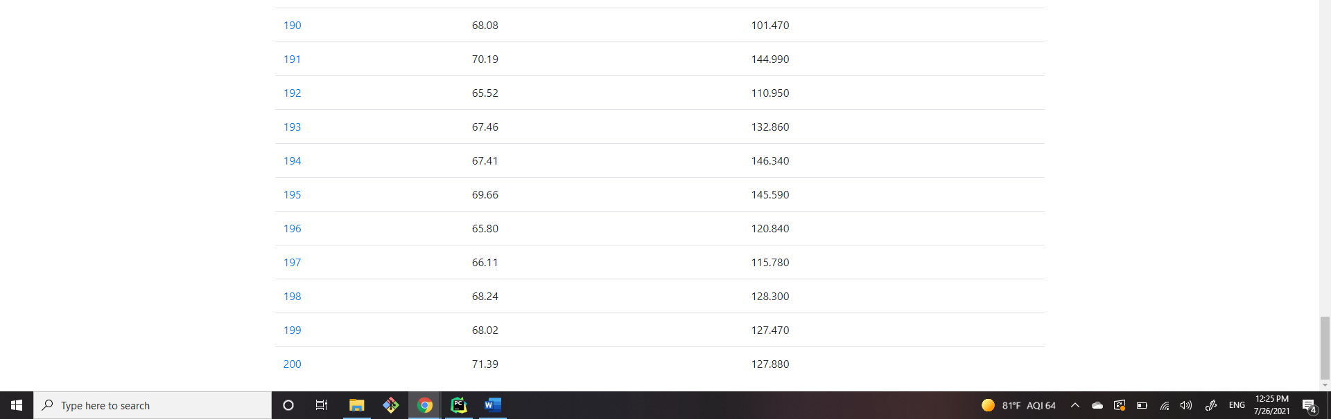Remove Record Screenshot